

**SOFTWARE REQUIREMENT SPECIFICATION (SRS) SIGN-OFF**

**Authorization Memorandum**

This form is to sign-off completion of the Requirement Phase for **CAMPUS MANAGEMENT SOFTWARE AT WORLD SKILL CENTER (WSC).**

World Skill Centre (WSC) acknowledges receipt of the deliverables as part of the Requirement Phase through the submission of this document.

|  |  |
| --- | --- |
| **MODULE NAME** | **Student Grievance Module** |

| **VERSION HISTORY** | | | |
| --- | --- | --- | --- |
| **Version** | **Author** | **Date** | **Changes** |
|  |  |  |  |
|  |  |  |  |

**WSC AUTHORITY NAME AND**  **SIGNATURE**

**SOUL AUTHORITY NAME AND**  **SIGNATURE**

Pages 1 of 9



# Logo Description automatically generated未标题-1

**Sustainable Outreach And Universal**

**Leadership (SOUL) Limited**

**Software Requirement Specification (SRS)**

Of

**Student Grievance module**

For Implementation of

**Campus Management Software**

at

**World Skill Center (WSC)**

**Table of Content**

**A. Abstract 3**

**B. Introduction 3**

**C. Definition, Acronyms and Abbreviations 3**

**D. Overview of the Document 3**

**E. Scope of Education Module 4**

**F. WSC Student Feedback Process Flow 4**

**G. Process Flow Description 4**

**H. List of Screen and their descriptions 4**

**I. Student Feedback 5**

**1.1 Student Feedback Questions 5**

**1.2 Student Feedback Form 6**

# Abstract

Software Requirements Gathering is one of the first phases of system development. This phase results in the Software Requirements Specification (SRS) document, which must contain a complete, concise, high-quality description of the system being considered.

# Introduction

The World Skill Center (WSC) is a premier advanced skill training institute established by the Government of Odisha, Skill Development and Technical Education Department, through the Odisha Skill Development Authority (OSDA). The WSC will impart advanced skill training in eight trades from engineering and service sectors. WSC caters primarily to induct the best talent from ITIs and Polytechnics and train them to become globally employable in emerging areas such as "Industry 4.0". WSC is housed in a state-of-the-art, 18-storey, air-conditioned building with nearly half a million square feet of space in the heart of capital city of Bhubaneswar.

With the Implementation of campus management software for WSC the goal is to streamline the operations and functions of the campus by integrating various processes, such as admissions, course registration, academic progress tracking, and financial management, HRMS, Procurement and Inventory management, etc into a unified system. The implementation also aims at providing a user-friendly interface for all stakeholders, making it easier for them to access the necessary information and complete their tasks with ease. The modules to be covered during the implementation of the software includes:

|  |  |
| --- | --- |
| Students Management Modules | Infrastructure Management |
| Academic System | Finance and Accounting System |
| Procurement & Inventory Management | Training and Placement |
| Human Resources Management System | Application Integration |

# Definition, Acronyms and Abbreviations

The following table explains the terms and abbreviations used in the document:

|  |  |
| --- | --- |
| **Abbreviation** | **Description** |
| SRS | Software Requirements Specification |
| SLCM | Student Life Cycle Management |
| R | Rename - When a field is Renamed |
| N | New - When a New field is Added |
| D | Delete - When an Existing field is Deleted |
| NA | Not Applicable |

# Overview of the Document

This requirement document provides a detailed overview of the functional requirements of a project. It serves as a communication tool between stakeholders, including developers, project managers, and end-users. The purpose of this requirement document is to define and document the project's objectives, scope, and expectations, and to ensure that all stakeholders have a clear understanding of what the project entails.

This document covers all the functional requirements of the **Student Grievance** **module** of ERP Product. This module helps in organizing the

# Scope of Education Module

Following functionalities are covered in this SRS document:

* Student Feedback

# WSC Student Feedback Process Flow

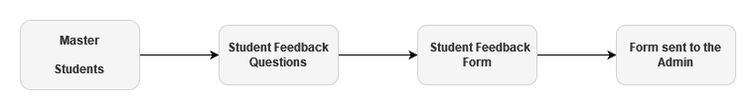

# Process Flow Description

**Students**

This is one of the master and required screen for feedback, where student information like their department , semester , programs , etc are stored

**Student Feedback Questions**

In this screen student feedback questions are defined and stored. Also question could enable or disable , which will allow the question to be available in feedback forms

**Student Feedback Form**

Student Feedback Form is the screen where students submits their feedback regarding an semester

# List of Screen and their descriptions

The following tables lists the pages used in Academics module :

|  |  |  |
| --- | --- | --- |
| **Sl no** | **Screen Name** | **Description** |
|  | Student | The Student document will hold all the data related to the students. |
|  | Student Feedback Questions | In this screen student feedback questions are defined and stored. Also question could enable or disable , which will allow the question to be available in feedback forms. |
|  | Student Feedback Form | Student Feedback Form is the screen where students submits their feedback regarding an semester |

# Student Feedback

## Student Feedback Questions

**General Description**

The following table describes overall information about this screen:

|  |  |
| --- | --- |
| **Description** | In this screen student feedback questions are defined and stored. Also question could enable or disable , which will allow the question to be available in feedback forms. |
| **Navigation** | None |
| **Pre-requisites** | None |
| **Existing Screen Name** | None |
| **New Screen Name** | Student Feedback Questions |

**Screenshot**

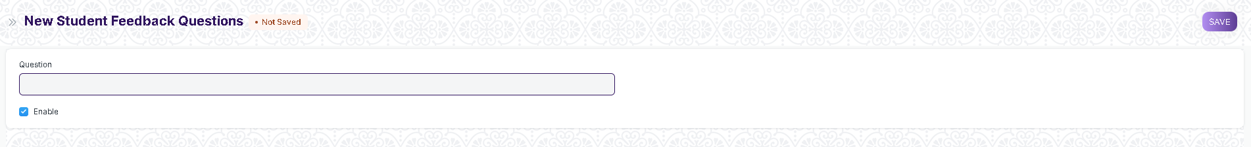

Figure 1 :Student Feedback Questions

**Field List**

The following table describes the UI fields present in this screen :

|  |  |  |  |  |  |  |
| --- | --- | --- | --- | --- | --- | --- |
| **ID** | **Field Name** | **Field Type** | **Mandatory** | **Validation/Action** | **Remarks** | **R = Rename ,**  **N = New ,**  **D =Delete** |
| 1 | Questions | Text |  |  |  |  |
| 2 | Enable | Check |  | If check then this question will appear in Student Feedback form |  |  |

**Users: Roles and Permissions**

The following table describes the users and their roles and permissions for the screens :

|  |  |  |  |  |  |  |  |  |
| --- | --- | --- | --- | --- | --- | --- | --- | --- |
| **ID** | **Role** | **Read** | **Write** | **Create** | **Delete** | **Submit** | **Cancel** | **Amend** |
| 1 | Education Administrator | Yes | Yes | Yes | Yes | NA | NA | NA |
| 2 | Student | No | No | No | No | NA | NA | NA |

## Student Feedback Form

**General Description**

The following table describes overall information about this screen:

|  |  |
| --- | --- |
| **Description** | Student Feedback Form is the screen where students submits their feedback regarding an semester |
| **Navigation** | Home > Admission > Feedback > Student Feedback Form |
| **Pre-requisites** | 1. Student 2. Academic Year 3. Academic Term 4. Programs 5. Semester 6. Course 7. Instructor 8. Questions |
| **Existing Screen Name** | None |
| **New Screen Name** | Student Feedback Form |

**Screenshot**

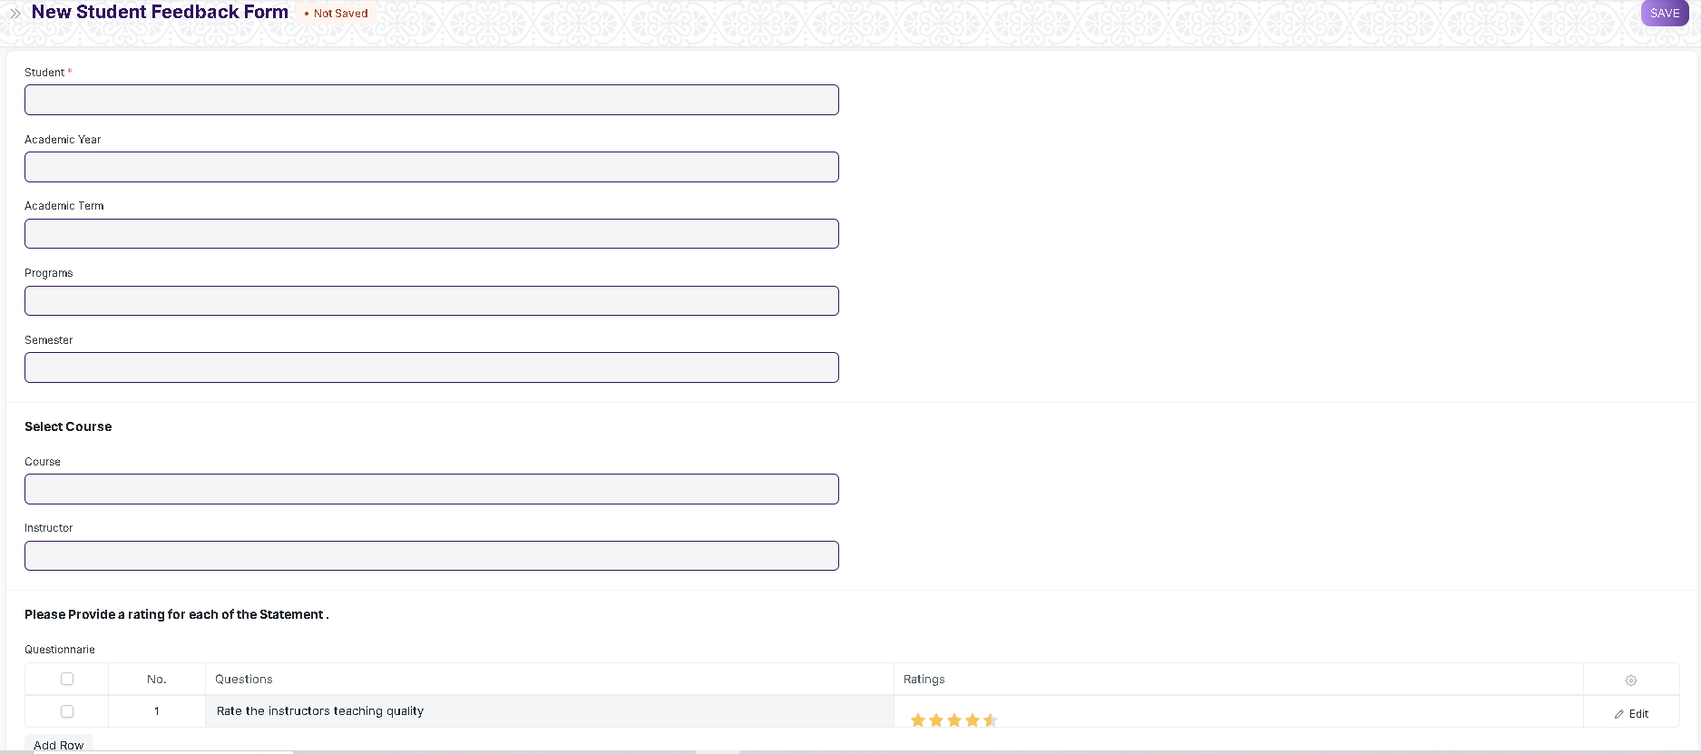

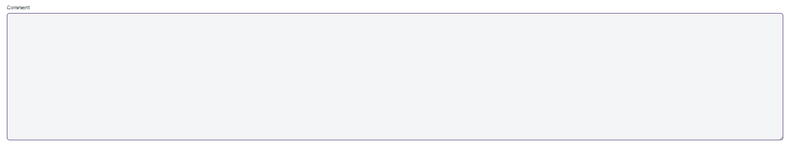

Figure 2:Student Feedback Form

**Field List**

The following table describes the UI fields present in this screen :

|  |  |  |  |  |  |  |
| --- | --- | --- | --- | --- | --- | --- |
| **ID** | **Field Name** | **Field Type** | **Mandatory** | **Validation/Action** | **Remarks** | **R = Rename ,**  **N = New ,**  **D =Delete** |
| 1 | Student | Link | Yes | Links to Student Screen |  |  |
| 2 | Student Name | Text Field |  | A read only field which is filled as per student selected |  |  |
| 3 | Academic Year | Text Field |  | A read only field which is filled as per student selected |  |  |
| 4 | Academic Term | Text Field |  | A read only field which is filled as per student selected |  |  |
| 5 | Programs | Text Field |  | A read only field which is filled as per student selected |  |  |
| 6 | Semester | Text Field |  | A read only field which is filled as per student selected |  |  |
| 7 | Course | Link |  | Links to Course Screen |  |  |
| 8 | Instructor | Link |  | Links to Instructor Screen |  |  |
| 9 | Questionnaire | Table |  |  | The details of the table is given below |  |
| **ID** | **Field Name** | **Field Type** | **Mandatory** | **Validation/Action** | **Remarks** | **R = Rename ,**  **N = New ,**  **D =Delete** |
| 10 | Question | Link |  | Links to Student Feedback Question |  |  |
| 12 | Ratings | Ratings |  |  |  |  |

**Users: Roles and Permissions**

The following table describes the users and their roles and permissions for the screens :

|  |  |  |  |  |  |  |  |  |
| --- | --- | --- | --- | --- | --- | --- | --- | --- |
| **ID** | **Role** | **Read** | **Write** | **Create** | **Delete** | **Submit** | **Cancel** | **Amend** |
| 1 | Education Administrator | Yes | Yes | Yes | Yes | Yes | Yes | Yes |
| 2 | Student | Yes | Yes | Yes | No | Yes | No | No |